Chapter X
Title of Thesis or Dissertation Chapter
This template presents a professional format to use for the chapter of a thesis or dissertation. Prepared by the Writing Guidelines for Engineering and Science Students (http://writing.eng.vt.edu/), this format is based on a professional format developed by Sandia National Laboratories for their formal reports. Following the chapter title, you should include at least one paragraph. In this format, 36 points of white space exist above the chapter line and 24 points exist below the title. No additional space, other than the 1.5 line spacing should exist between the line with the chapter number and the chapter title. For the chapter title, use a bold sans serif typeface (Arial is a good choice, as is Arial Narrow). The size of the title should be larger than the size of the text and in initial capitals. In this format, 18 points is suggested, but 14 points can work as well.
Like every major publisher in the world, the Writing Guidelines for Engineering and Science Students recommends indenting paragraphs. In addition, no line skip exists between paragraphs, because such line skips distort the hierarchy of headings and subheadings. Please do not buy into the format of not indenting paragraphs and skipping a line between each paragraph. This format was developed for early word processing programs that could not create indents. This format, which is primitive, also exists on the web, because some browsers cannot recognize paragraph indents.
First Heading
Headings are 14 points, flush left, and boldfaced. Use initial capitals. To preserve hierarchy, allot 30 points before the heading and 18 points after. A common question is whether you should number your headings (for instance, 1.1 and 1.2 in Chapter 1). Such numbering, while not necessary, is sometimes expected by thesis advisors and can help committee members focus their discussions. Although using numbers on headings is justifiable, numbering on subheadings (1.1.1) is silly and makes a complex document appear even more complex.
At least one paragraph should follow a subheading before a sub-subheading exists. The typeface given here for the text portion of thesis or dissertation is Times New Roman (on a Macintosh, Times would a comparable choice). Book Antiqua would also be a professional choice, especially for the single column format of a thesis. On a Macintosh, comparable typefaces to Book Antiqua are New Century Schoolbook and Palatino. The recommended spacing for a thesis or dissertation is space and a half—double space is too much and single spacing makes it difficult for reviewers to insert comments.
First Subheading
Subheadings should be 12 points and boldfaced. Skip 18 points before the sub-subheading and 6 points after. Use initial capitals. Note that subheadings are usually not listed in the Table of Contents. Be conservative with subheadings in a thesis or dissertation. A thesis or dissertation is essentially an argument and, as such, requires series of uninterrupted paragraphs to state assertions and present evidence for those assertions. Avoid sub-subheadings, because they are unnecessary in a thesis or dissertation. For instance, Richard Feynman wrote his famous Feynman Lecture Series on Physics (more than 600 pages) using just chapter titles and headings. Rather than having sub-subheadings, which would be a fourth level heading in a thesis or dissertation, have your paragraphs show the arrangement of your ideas.
Second Subheading
If you have one sub-subheading, you must have a second. Otherwise, the first sub-subheading has nothing to be parallel with. As mentioned before, even though you might decide to associate numbers with your headings, avoid doing so for subheadings. Do not allow a heading or subheading to stand as a widow line at the bottom of a page. If the situation occurs, force a line break before the heading or subheading.
Second Heading
If you have one heading, you must have a second. Otherwise, the first heading has nothing to be parallel with. Another formatting consideration concerns the incorporation of figures and tables. Shown in Figure 1-1 is a common format that serves theses and dissertations well. Note that the format of the figure name given here is for the first figure in Chapter 1. If this figure were the first figure in Chapter 2, it would have the name Figure 2-1. Also note that the word figure is not abbreviated. In a single column document, such an abbreviation makes no sense. A period is the powerful piece of punctuation—its primary use is to end sentences. Do not dilute its power by having it do menial tasks such as saving three letters from a word that is short to begin with.

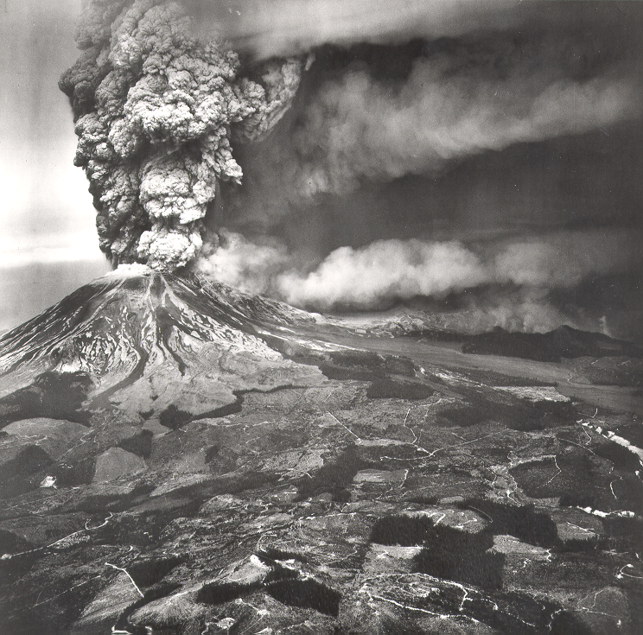
Figure 1-1. The eruption of Mount St. Helens [USGS, 1980]. Because of its suddenness and its size, the eruption of Mount St. Helens caused the deaths of more than sixty people, most of them scientists studying the volcano.

Following standard convention, the formal introduction of Figure 1-1 occurred in the text before the figure appeared. In the introduction of an illustration, using pointers such as below or on the next page is undesired. Your technical reader knows where the illustration is supposed to be placed—after the paragraph that introduces it or on the next page if not enough space exists below the paragraph. Note that you should not break paragraphs in a Microsoft Word document to insert an illustration. To distinguish the figure caption from the text, you should place the figure caption in a smaller typeface, as was done in Figure 1-1. Recommended for the line spacing of the caption is single spacing. For the caption, a nice touch is to place the name in the bold sans serif of the headings and have the caption’s text in the serif typeface of the chapter’s text. As is common in reports, the caption begins with a phrase and is followed by a sentence (or two) that explains unusual details.
Tables are presented in a different fashion. For instance, Table 1 presents an example. The heading for the table goes above and is the same type size as the text of chapter. The heading is a single phrase. If there are unusual details, those are explained in footnotes beneath the table. Note each line skip above and below that separates each illustration and its caption (or heading) from the text.

Table 1-1. Physical characteristics of the planets [Handbook, 1969].
Planet | Diameter  (km) | Gravity  (earth ratio) | Year  (earth days) | Temperature  (K)
Mercury | 5,100 | 0.40 | 88 | 700
Venus | 12,600 | 0.90 | 225 | 700
Earth | 12,800 | 1.00 | 365 | 350
Mars | 6,900 | 0.40 | 687 | 320
Jupiter | 143,600 | 2.70 | 4,333 | 150
Saturn | 120,600 | 1.20 | 10,759 | 138
Uranus | 53,400 | 1.00 | 30,686 | 90
Pluto* | 12,700 | ??? | 90,885 | 80
*Corresponding data on Neptune not available.

In a thesis or dissertation in engineering or science, reference listings are usually given as [author, year] or as [reference numbers]. The corresponding citations usually appear in a separate section at the end of the document—after the appendices and glossary. The format for an appendix is the same as the format for a chapter, except that illustrations for Appendix A are numbered Figure A-1, Figure A-2, Table A-1, Table A-2, and so forth. Likewise, in Appendix B, illustrations are numbered Figure B-1 and so forth.

